ECE411 Lab3 Report

RUI ZENG 1003979091

**4.1 Effects of Quantization**

**1)**

Modulus of the complex pole:

Thus, the poles are stable.

**2)**

Quantize K:

Quantize transfer function of C(z):

Simulink Diagram:

From graph, with the quantization of K and C(z) the output no longer converges.

**4.2 Improving Controller Realization**

Quantize K:

图形用户界面

Quantize C1(z):

Quantize C2(z):

Quantize C3(z):

Simulink Model:

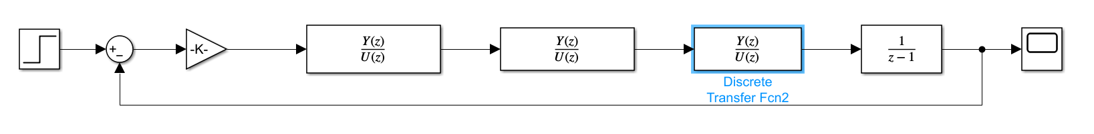

**4.3 Existence of Limit Cycles**

Quantization interval set to 0.2:

Simulink Model:

From graph above, at K = 1.0001, the limit cycle emerges.

**4.4 Controller Implementation for Step Tracking and Disturbance rejection**

**手机屏幕截图

**

**Controller 1 with C(z) quantized:**

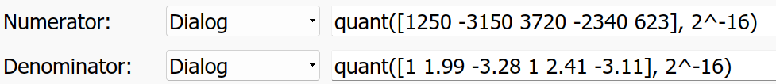

The step tracking is achieved in 1 second.

The disturbance rejection is achieved.

Mild oscillation after entering the steady state.

The transient response has oscillation with amplitude of oscillation of 6.

**Controller 2 with C(z) quantized:**



The step tracking is achieved in 3 second.

The disturbance rejection is achieved.

No obvious oscillation after entering the steady state.

The transient response has oscillation with amplitude of oscillation of 2.

**Compare controller 1 and 2.**

Controller 1 has poles placed at 0 while controller 2 has poles a small distance from origin.

Both controller successfully track the step response.

Controller 1 has faster converging speed to reach steady state but has larger oscillation before entering the steady state.